SERVERLESS EXPENSE TRACKER STATICS WEB SERVER ON AWS

VINEETH KUMAR M
Febuary Batch
3:30PM to 5:00PM

INDEX:

INTRODUCTION

AWS SERVICES

DIAGRAM

EXPLANATION

OUTPUT

CONCLUTION

INTRODUCTION:
This project is a Serverless Expense Tracker Web Application developed using Amazon Web Services (AWS) via deployed using. The front-end is hosted via S3 static web. Backend database has connected with Lambda function (python 3.13 version) via API Gateway storing data handled by DynamoDB.

AWS SERVICES:
- DYNAMO DB: Data is stored in tables using primary keys such as expense_id. And integrates easily with AWS services like Lambda and API Gateway.
- LAMBDA FUNCTION: Create a function for backend server with (python 3.13) to fetch the static web site hosted on S3.
- API GATEWAY: Create Rest API method to invoke through dynamodb.
- S3 bucket: Hosted the public frontend web server via (HTML CSS AND PYTHON).

DIAGRAM:
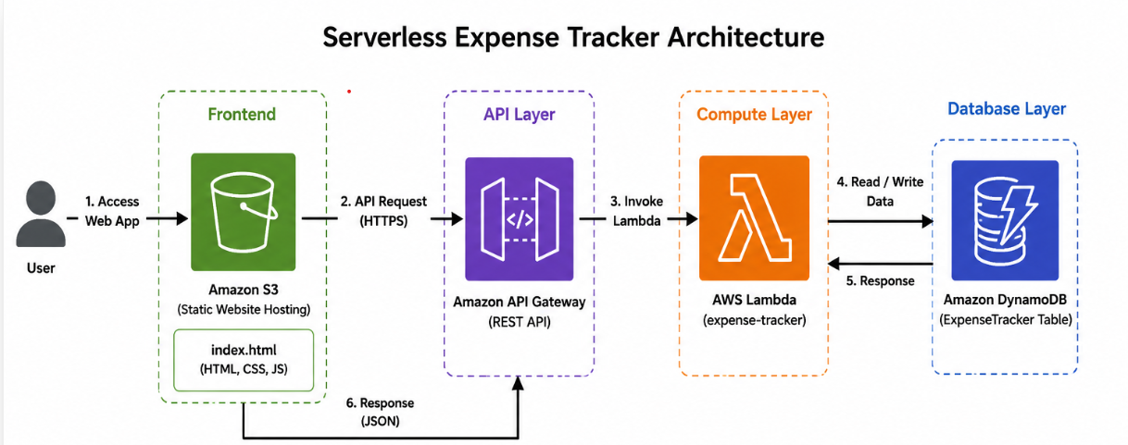

EXPLANATION:
- Hosted the S3 static frontend website for expense tracker.
- Create a LAMBDA function and execute the python code to connect the DB table to store data.
- Created an API resources for expenses.
  - Create post method with Rest API and attached the lambda function and deploy.

INSTRUCTIONS:

DYNAMODB
- Create a Dynamodb table for expenses
- Define partition key expensed_id
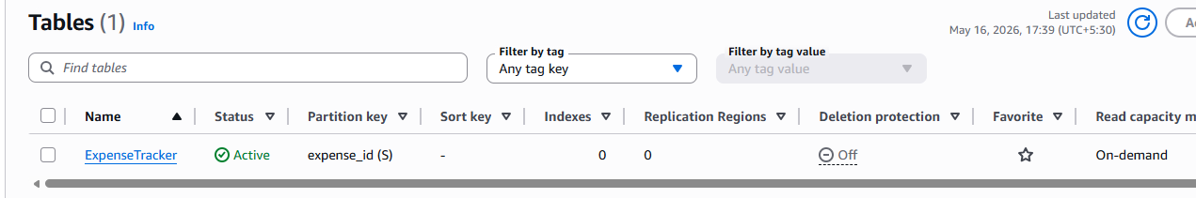

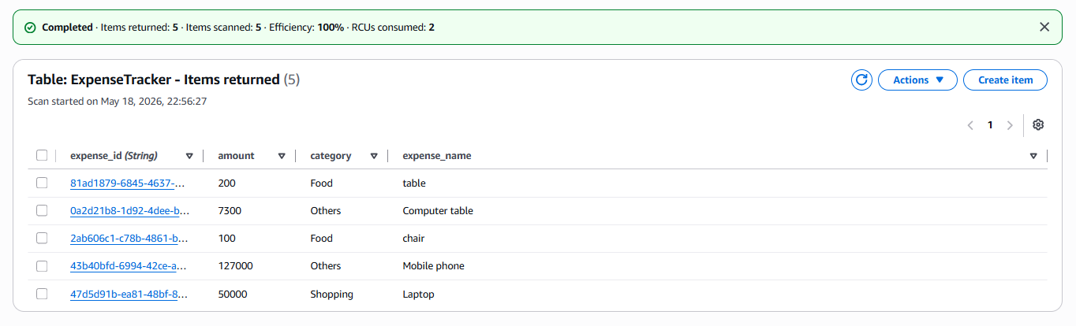

API GATEWAY:
- Create a Rest API in API Gateway.
- Add Resources and method
  - Post – post the data in Lambda.
  - Enable the lambda proxy integration to send all request.
- Enable CORS and deploy API, API URL has created.
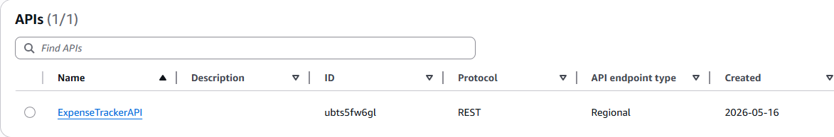

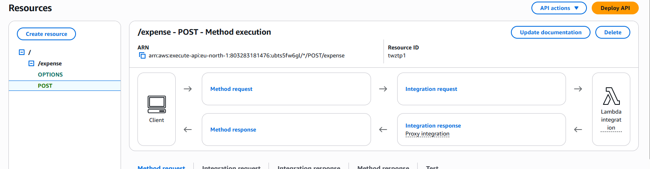

Lambda function
- Create a Lambda function deploys the python code.
- Enable the lambda proxy to get the request.
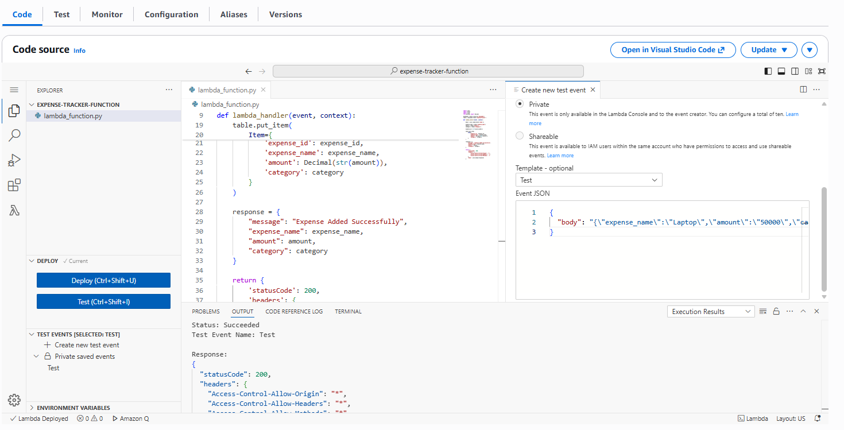

S3 Storage Bucket
- Create a Static front end web page as public.
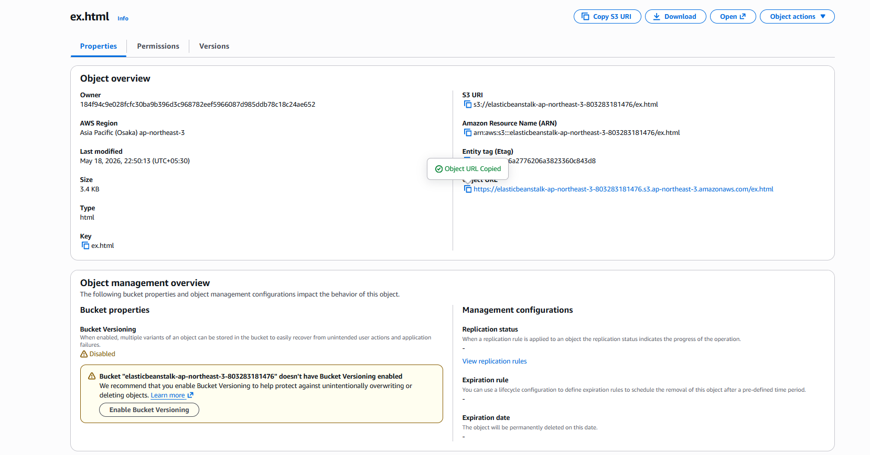

FRONTEND:
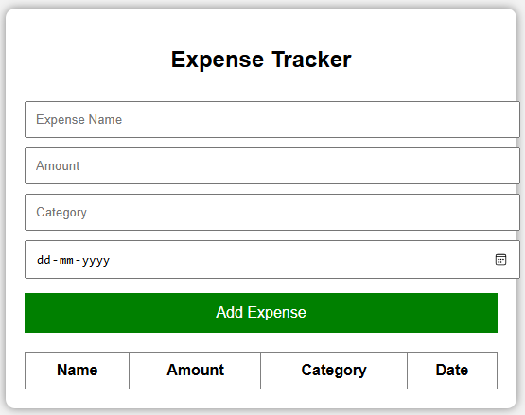

OUTPUT
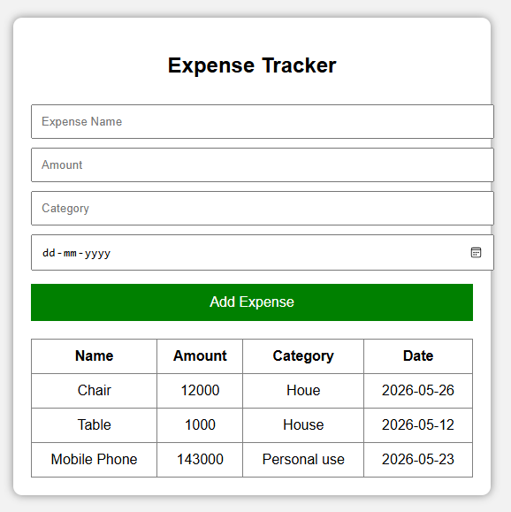

CONCLUSION:
The Serverless Expense Tracker application was successfully developed using AWS cloud services such as Amazon Web Services, Amazon S3, Amazon API Gateway, AWS Lambda, Amazon DynamoDB,
The frontend was hosted in S3, API Gateway handled REST API requests, Lambda processed the business logic, and DynamoDB stored the expense details.

